# **GIT Instruction**

As a result of next 2 modules, you should have **only 3 brunches**:

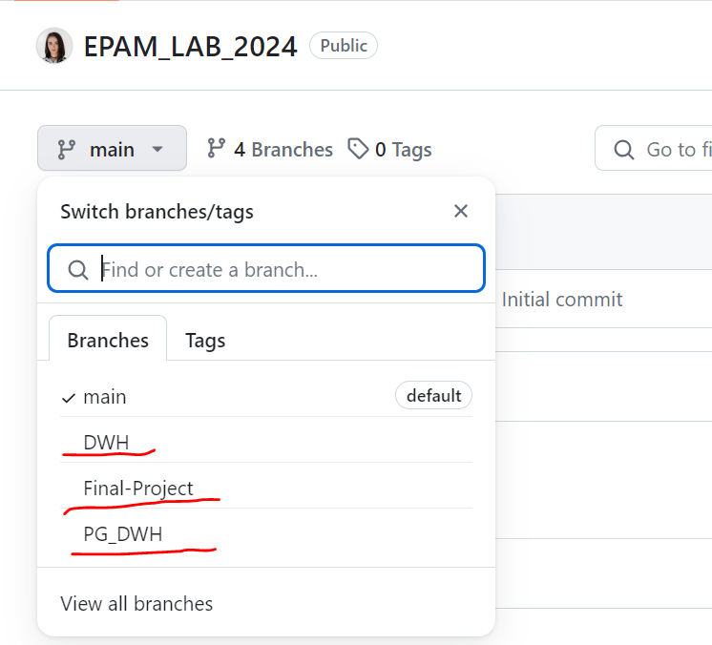

* “DWH” brunch – for “Introduction to Data Warehousing and ETL. Part 1”.
* “PG_DWH” - for “Introduction to Data Warehousing and ETL. Part 2”.
* “Final Project” - for all scripts for your final project (scripts + final version of Business Template).

Please! Name all your commits like: “**Task N committed**”. This is how your mentor will understand which changes in Business template you did.

1. **‘DWH’ brunch**

**Task 1:** you need to add information about your sources and add your source file.

1. In “Task 1” folder you should place your source file
2. “Business template” file should be outside folders (as on a screenshot below!), just directly in your repository and “DWH” brunch!!! Because you will update this file every time you make some changes inside it.

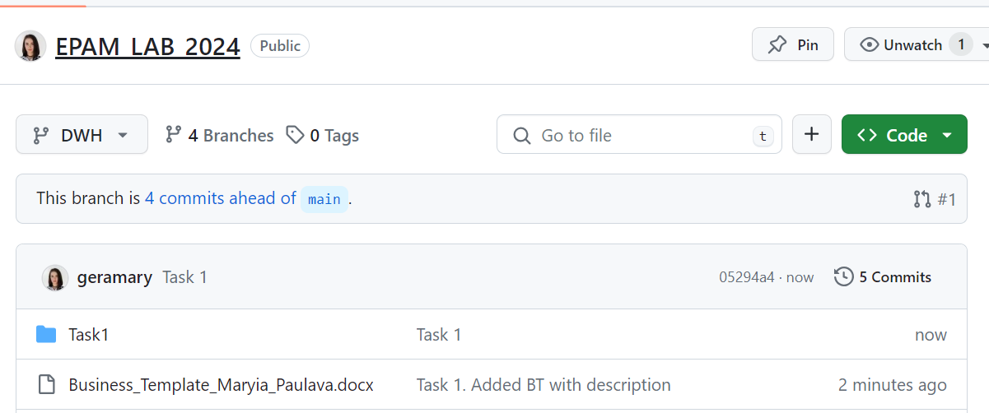

**Task 2:**

The result should be present in your GIT repository:

* + Update the document 'Business_Template.docx'
  + Create sub-folder Topic_02 and commit png files + description (docx)

How it should look like (new folder Task 2 + changes in Business template file):

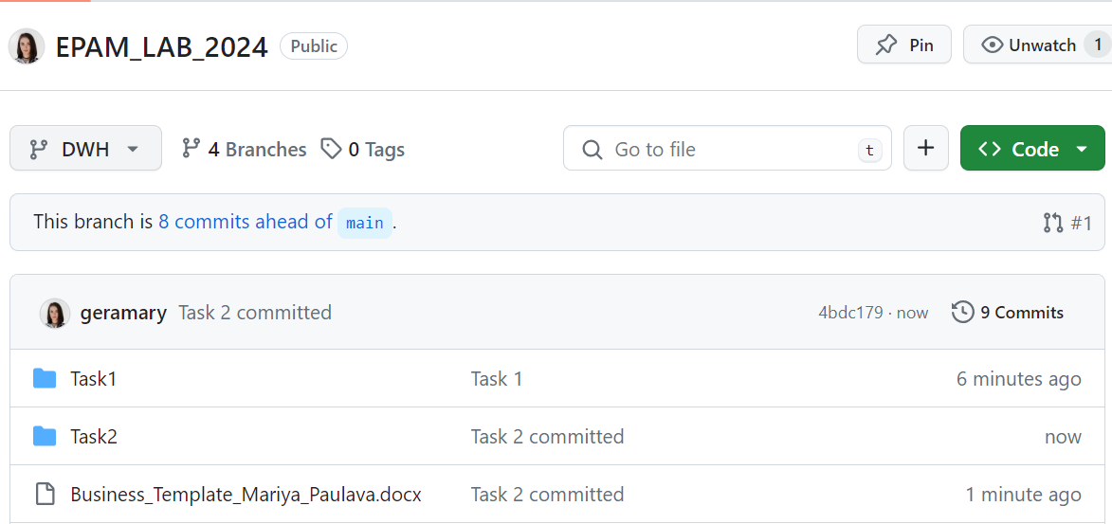

**Task 3- Task 9:** same idea.

1. **‘PG_DWH’ brunch:**

As in "PG_DWH" Brunch we do not work with Business template – you should create folders for each Task and commit all files in separate folders.

1. **‘Final Project’ brunch:**

This brunch will contain all necessary scripts for your Project Presentation AND **final version** of Business template (with all fixes regarding mentor’s comments).

Please follow mentioned structure of your Final Project folders (according to your structure for sure):

